Young patient where one ear has disease that eroded a lot of the bone and other ear is healthy

Deep sinus tympani

Axial view

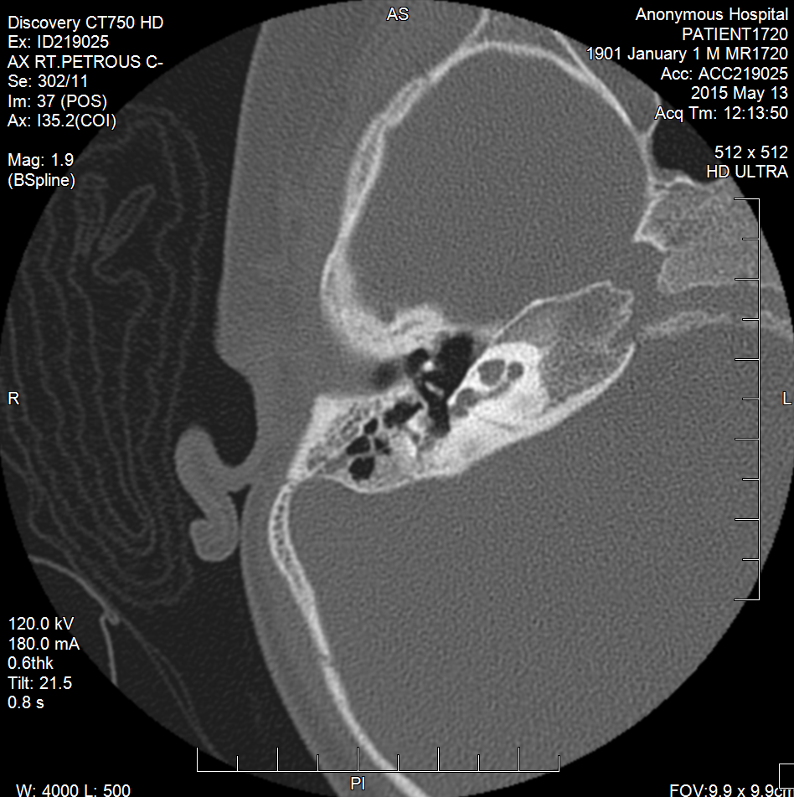

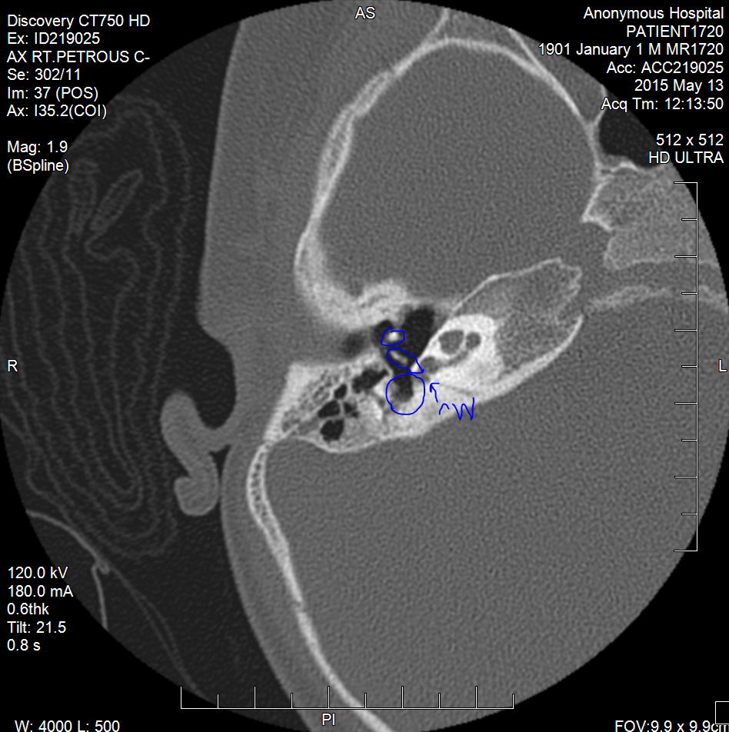

3

2

1

1 & 2 – ossicular chain

1 – malleus

2 – incus

3 – sinus tympani

Arrow points to the round window

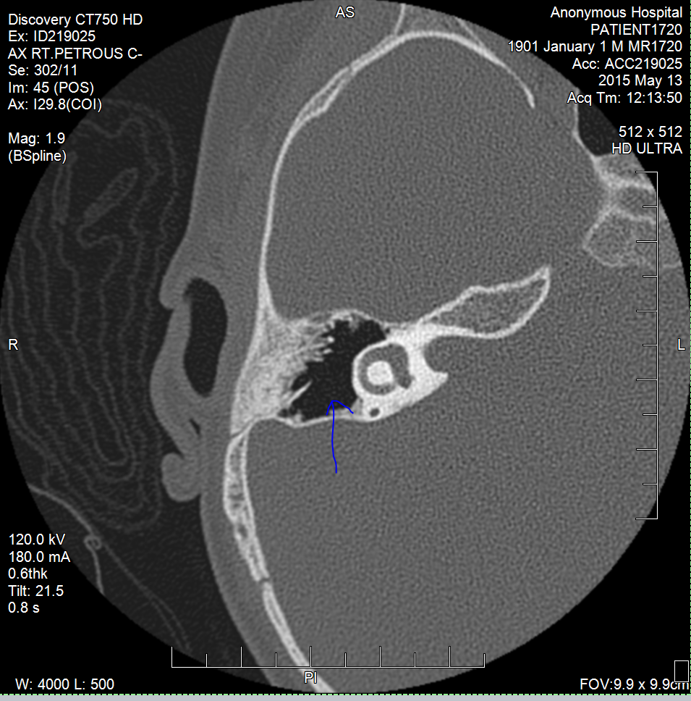

Antrum

Lateral semicircular canal shown (circular bit beside the antrum) -> 3D model in this plane, the antrum can have the tip

Want to reach around where the arrow is pointingin the antrum

Normally in TEES, the semicircular canal limits the reach of the instrument but if there is something that can reach here, that would be a better accessibility instrument

Show that the new instrument can reach here – video this or a screen shot -> get a shot of the instrument coming in from ear canal and then into the antrum and into this section

Video of tip of instrument moving around this section in antrum

Show where we can normally reach & range of reach (with panetti and thomassin) and then how a new instrument can reach

Use colour to show how much different ranges of reach of tips of instruments (shade in the reaching range of different instruments)

Saggital view

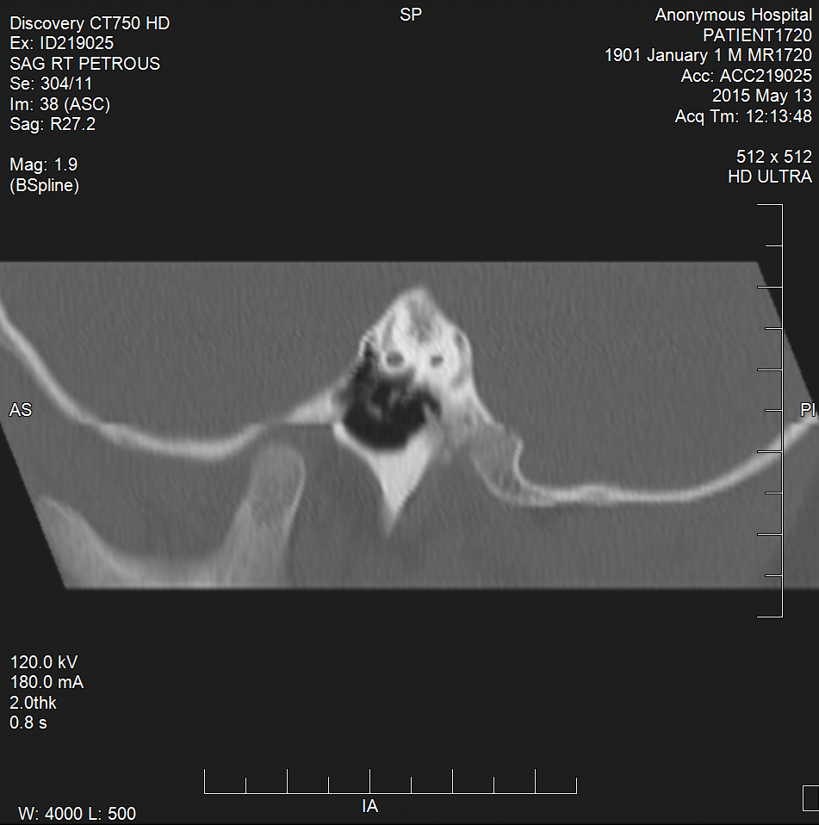

Space above ossicular chain

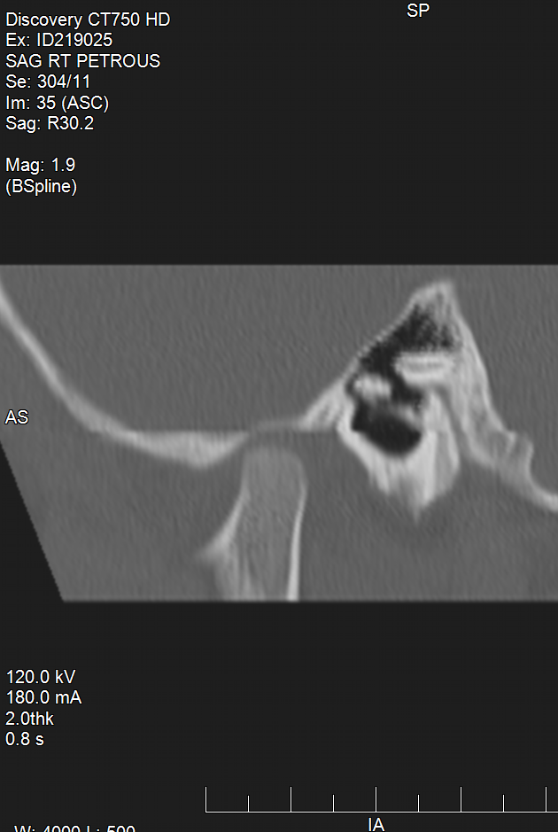 Space superior to ossicular chain (above)

ossicles

Tegman tympani – roof of ear space

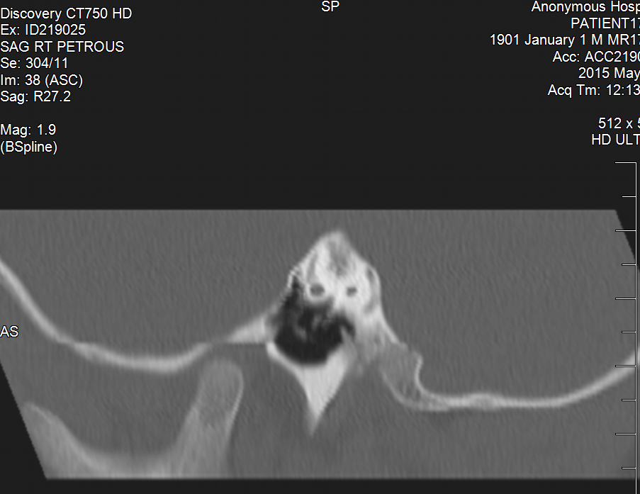

Sinus tympani

<https://users.fmrib.ox.ac.uk/~stuart/thesis/chapter_3/chapter3.html>

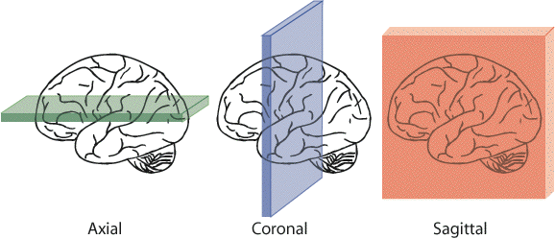

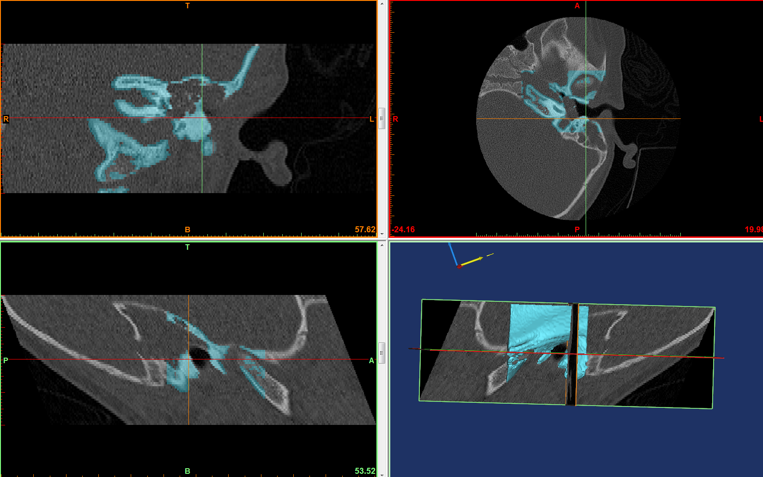

Sagittal

Coronal

Axial

Note: use the 3D model to help navigate the planes to understand what each section is showing – that will help find and then outline the sinus tympani, antrum, etc.

Axial section can be used to find and outline the sinus tympani and round window niche – use mimics to do that

Axial section: reference: <http://emedicine.medscape.com/article/875593-overview#a4>

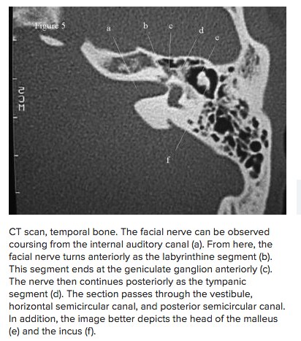

ossicles

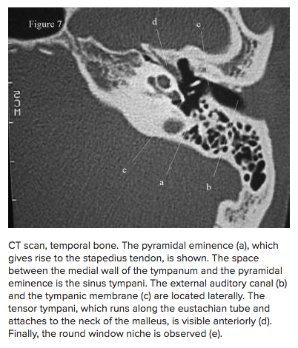

Round window niche, sinus tympani

coronal view:

find the circled area in the coronal view and outline with a different mask – space superior to malleus needs to be accessed by instrument.

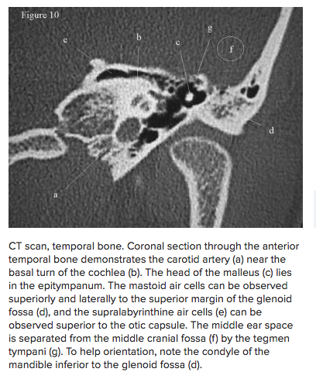

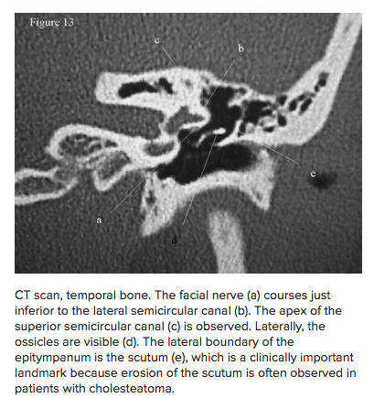

Spot superior to ossicles